Choosing your courses

The first thing to do, if you haven’t already, is make sure you sign up to the UCAS Hub.
This will give you all the tools and information you need in one place. You can easily explore, filter, and favourite the things which matter to you most.
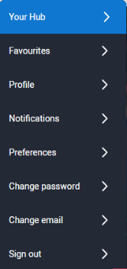
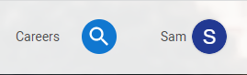
How do I sign up?
The UCAS Hub is free and easy to use. All you need to do is follow these three simple steps to sign up:
Step 1 – Register
To get started, visit ucas.com/hub.
Step 2 – Verify your account
Once you’ve completed your registration details you’ll be asked to verify your account by entering a code we’ve emailed you.
All you need to do is copy the code from the email and hit the verify button.
Step 3 – Sign in
Now you’re ready to sign in and start exploring! The first time you do, we’ll ask you some extra questions so we can help you find the right info.
At any time to pick up where you left off, click ‘Sign in’ on the top right-hand side of any page on ucas.com, and navigate to ‘Your hub’.

Activity 1: What you have learnt so far?

Using all the research you have done so far, jot down answers to the questions below – this will help you focus on choosing specific courses you might apply to. Remember to go back and look at the ‘Favourites’ you have selected as you explored the UCAS Hub and ucas.com.

What are your favourite subjects? Are these where you get your best marks or have you found new ones that really appeal?
Are you more interested in studying a single subject (such as maths, history, French, chemistry) or something that has a more vocational link (such as retail, software design or engineering)?
If you have a career you’re really interested in, do you need particular degree subjects or qualifications?
Are you interested in doing a work-based placement as part of your degree course or a study abroad option? It makes your course longer (four years), but means you get experience in other areas.
Do you have preferences for the location or sort of university or college you want to attend?

Activity 2: Broaden your horizons
There are over 35,000 courses you can choose from, so have a go at these tasks to help find the perfect courses for you. You can use the UCAS Hub to ‘Explore’ courses based on your favourites – but don’t forget to also ‘Search’ other courses on offer. The filters will help you sort by subject, entry requirements, location, and much more.

Try to find:
 | 1 | 2 | 3
- three courses that link directly to your favourite subject area

- three different courses related to each of the subjects you are currently studying

- three courses you have never heard, or thought, of before

UCAS Hub top tip
You can add as many courses as you like to your UCAS favourites, and quickly navigate back to them using the drop-down list on your profile.
All your favourites are in one place – subjects, courses, universities and colleges, locations, pages, and career pathways.

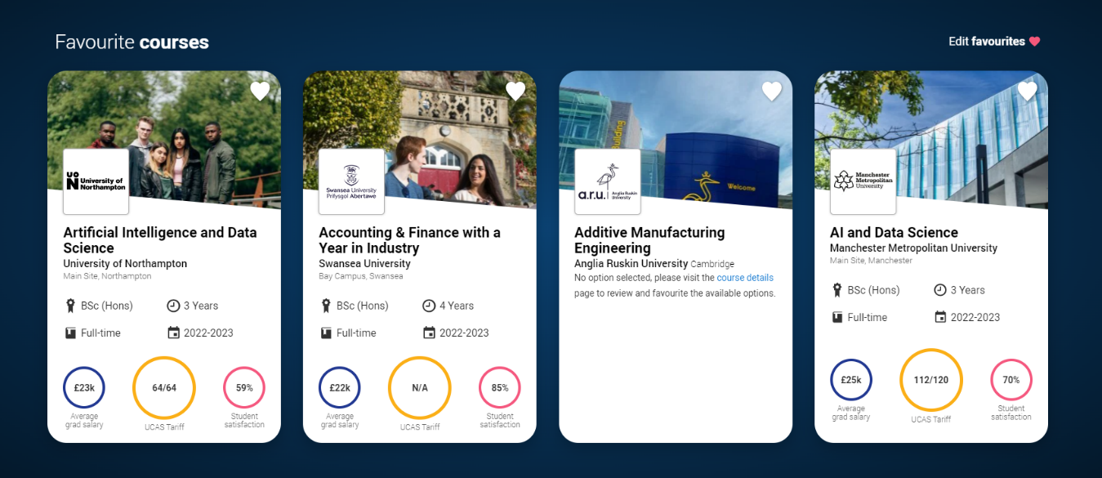

Activity 3: Choosing the right course

We all have different ways of learning, which ultimately influences success on a course. You should think carefully about each of the courses you’re interested in, to make sure they’re right for you. Use the following ideas for research to complete the table below with as much information as possible – tick off each one once you have done it.

- Open days, events and virtual tours: Sign up to an open day or take a virtual tour for each of your choices.

- UCAS search tool: If you’ve favourited courses on your Hub, make sure you click through to read about each course in more detail. You’ll see a course summary, entry requirements, fees and funding, and much more.

- University and college websites: Make sure you visit each university or college website to read more about the course you might apply to.

What you need to find out | Subject/course 1 | Subject/course 2 | Subject/course 3 | Subject/course 4 | Subject/course 5
- Entry requirements: Do they match my subjects/grades? Are there admissions tests? Will there be an interview? Does the course description mention skills or experience you might need?
If you have predicted grades, consider applying for at least one course with lower entry requirements to have as a reserve offer.
- Does the course match my interests: What module choices and content does it offer? Do they relate to my career plans? Am I happy with both the core and optional modules? Consider all years of the course.
- Teaching and assessment: How is the course taught? What is the split between formal teaching and independent study? How much time will I spend in lectures or seminars? How is the course assessed – exams or coursework? Does this suit you?

- Costs: What are the tuition fees and likely living expenses? Are there any scholarships or bursaries on offer?
- Work experience: Does the course or university offer any internship or placement opportunities? What have other graduates gone on to do? Are there links to employers and support for career development?
- Professional accreditation: Do you need this for your chosen career path? If so, is the course recognised by appropriate professional bodies?
- What are three pros and cons of this subject/course?
- Reflection: What is the real likelihood of you applying to this course.
(Rank 1 – 10, with 10 being most likely.)

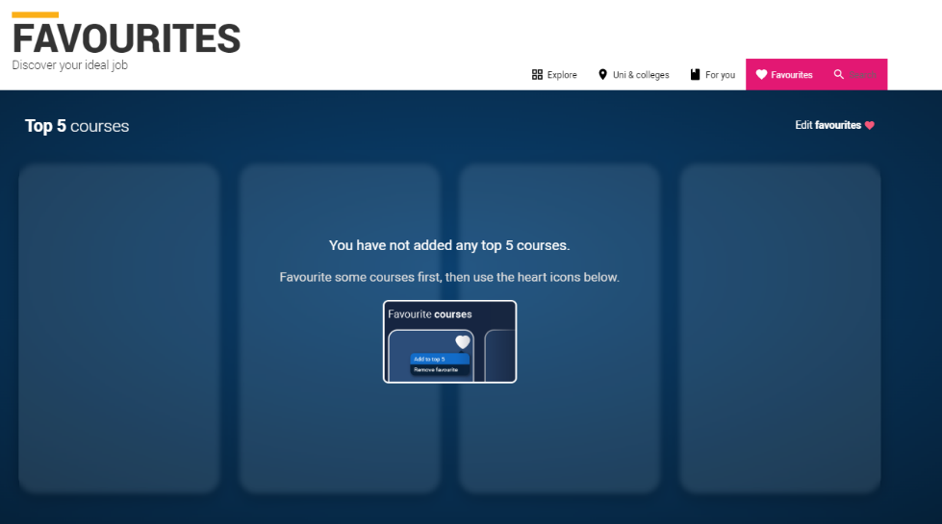
UCAS Hub top tip

Now you’ve researched the details of your top choices use the ‘Top 5’ feature to think about the range of courses you might apply to. Move your favourites in and out of the Top 5 to find your perfect combination. Think about the range of choices you have. Make sure you have a spread of options to give you the best chance of being made offers.

Double-check the entry requirements. Universities and colleges set their own entry requirements for higher education courses, and these vary widely depending on the subject, the specific course, and the course provider. They set the entry requirements for each course to ensure you have the right skills and knowledge to successfully complete it. These might be qualifications, subjects, grades, skills, experience – and in some cases, an admissions test or interview.

Your ‘Top 5’ doesn’t need to be finalised until you make your application, so play around with it to see what suits you best!

